

Data Structures and Algorithms (23CSE203)
LAB MANUAL
Submitted By:
Name | MAHESWARAN R
Roll No | AV.SC.U4CSE25127
Year/Sem/Section | 2 nd YEAR /SEM-3/CSE-B
Date of Submission
Submitted To:
Name | Dr. Raj Kumar Batchu
Department | CSE
Designation | Assistant Professor, School of Computing

INDEX
SNO | LAB PROGRAM | PAGENO | REMARKS
1.
2.
3.
4.

5.
6.
7.
8.
9.
10.
11.
12.

LAB-1
1)Aim:- A rocket launch system displays a count down before launch. Instead of using a loop implement the count down using a recursion ,write a recursive program to display a count down from n to 1 followed by “Launch”
CODE:
def countdown(n):
if n==1:
return "LAUNCH"
return countdown(n-1)
n=int(input("enter the value of n:"))
print(countdown(n))
OUTPUT:
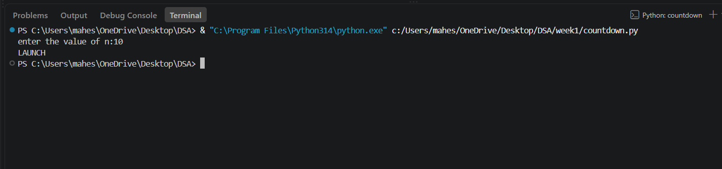
Explanation:
· The function launch(n) prints the current value of n.
· If n is greater than 0, it decreases n by 1 and calls itself recursively.
· The recursion continues until n becomes 0, which is the base case, and the function stops.
Error Table:
No errors

2)Aim: An Hr department stores employee ID in a list . Develop a recursive program to search for a given employee ID write a recursive function to search for an employee ID . Write a recursive function to search for an employee ID in a list.
CODE:
def search(i):
l=[1001,1002,1003,1004,1005]
for j in range(len(l)):
if l[j]==i:
return j,i
else:
return("emp id not found")
return search(i)
i = int(input("enter the id to be searched:"))
print(search(i))
OUTPUT:
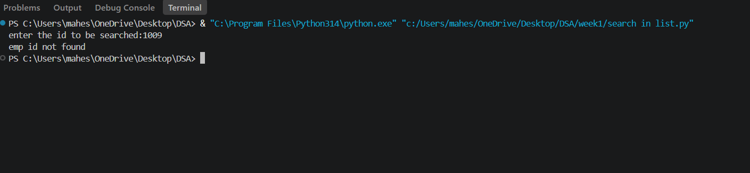
EXPLANATION:
This program uses recursion to perform a linear search for an employee ID (or any target element) in a list.
- The function empid_Search(arr, target, n=0) is defined with three parameters:
  - arr: The list in which the search is performed.
  - target: The element to be searched.
  - n: The current index, initialized to 0.
- The statement if n == len(arr): return -1 is the base condition. It checks whether all elements in the list have been examined. If the end of the list is reached without finding the target, the function returns -1.
- The statement if arr[n] == target: return n compares the current element with the target. If they are equal, the function returns the current index where the target is found.
- If the current element does not match the target, the function calls itself recursively with the next index using return empid_Search(arr, target, n + 1).
- The list arr = [10, 20, 30, 50, 607, 809, 506] is created, and the function is called to search for the element 50.
- The returned value is stored in the variable result.
- If result is not equal to -1, the program prints the index where the element is found. Otherwise, it prints "Element not found."

ERROR TABLE:
No errors

3)Aim: Banks calculate the growth of an investment using compound interest. The formula requires calculating powers, which can be implemented recursively. Write a recursive program to calculate power.
CODE:
def pow(p,n):
if n==0:
return 1
return p*pow(p,n-1)
p=int(input("enter the value of p:"))
n=int(input("enter the value of n:"))
print(pow(p,n))
OUTPUT:
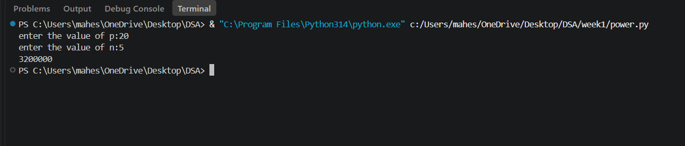
EXPLANATION:
- The program is used to find the power of a number (pⁿ) using recursion.
- It takes two inputs from the user:
- p → Base number
- n → Exponent (power)
- The function power(p, n) is called to calculate the result.
- If the exponent n is 0, the function returns 1 because any number raised to the power 0 is
- If n is not 0, the function calls itself with n - 1 and multiplies the result by p.
- This recursive process continues until the exponent becomes 0.
- After reaching the base case, each recursive call returns its result, and the final value of pⁿ is obtained.
- The result is stored in the variable result.
- Finally, the program prints the calculated power of the given number.
ERROR TABLE:
No errors
4)Aim: Write a recursive python program for fibanocci series , print first n terms series.
CODE:
def fibbanacci(n):
if n<=1:
return 1
return fibbanacci(n-1)+ fibbanacci(n-2)
n=int(input("enter the value of n:"))
for i in range(n):
print(fibbanacci(i),end="")
OUTPUT:
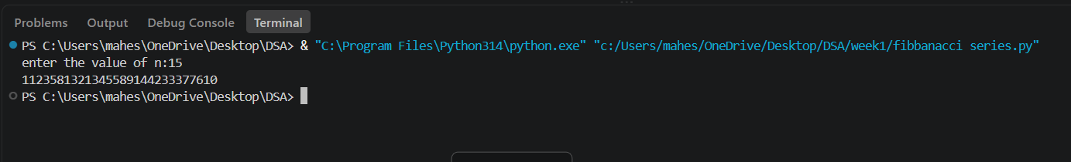
EXPLANATION:
- The program uses a recursive function fib(n) to generate Fibonacci numbers.
- The base condition returns 0 when n = 0 and 1 when n = 1.
- For values greater than 1, the function returns the sum of the previous two Fibonacci numbers: fib(n-1) + fib(n-2).
- The user enters the number of terms (n) to be displayed.
- A for loop calls the fib() function repeatedly for each term from 0 to n-1.
- Finally, the program prints the Fibonacci series in sequence.
ERROR TABLE:
Error | Correction
Function name spelling | Change it to fibonacci.
Negative input | Check that n >= 0 before running the loop.

5)Aim: In a logistic company , the number of possible ways to arrange n different parcels is calculated using the factorial formula (n!) , develop a recursive program to calculate factorial of a given number.
CODE:
def fact(n):
if n == 0 | n == 1:
return 1
return n* fact(n-1)
n= int (input("enter the value:"))
print(fact(n))
OUTPUT:
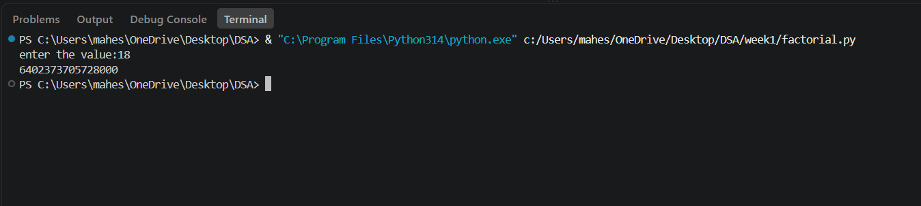
EXPLANATION:
- The program defines a recursive function fact(n) to calculate the factorial of a number.
- The base condition checks if n <= 1. If true, it returns 1 (for factorial, 0! = 1 and 1! = 1).
- Otherwise, the function returns n * fact(n-1), multiplying the current number by the factorial of the previous number.
- The function is called with the value 6.
- Finally, the program prints the factorial of 6, which is 720.
ERROR TABLE:
Error | Correction
Indendation error | Give proper indendation
Negative input | Check that n >= 0 before running the loop.

LAB-2
1)Aim: - Write a program to perform linear search on the given input.
CODE:
def linear_search(arr,key):
for i in range (len(arr)):
if arr[i] == key:
return i
return -1
n = int (input("enter number of elements:"))
arr = []
print("enter the elements:")
for i in range(n):
arr.append(int(input()))
key = int(input("enter the element to search"))
result = linear_search(arr,key)
if result != -1:
print("element found at index", result)
else:
print("element not found in the array")
OUTPUT:
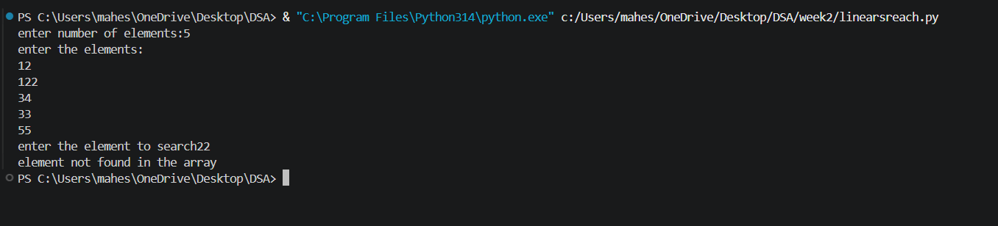
EXPLANATION:
This program uses a linear search technique to find a target element in a list.
- The function linear_search(arr, target) is defined with two parameters:
  - arr: The list in which the search is performed.
  - target: The element to be searched.
- A for loop is used to traverse each element of the list from index 0 to len(arr) - 1.
- The statement if arr[i] == target: compares each element of the list with the target element.
- If the element is found, the function returns "at position", i + 1, which gives the position of the element (starting from 1).
- If the loop completes without finding the element, the function returns "element not found".
- An empty list a is created, and the user is asked to input elements continuously.
- The loop continues until the user enters "stop", after which the input process ends.
- The user then enters the element to be searched, which is stored in variable b.
- The function is called using linear_search(a, b) and the result is printed.

ERROR TABLE:
Error | Correction
Indendation error | Give proper indendation
Negative input | Check that n >= 0 before running the loop.
Empty array | Check that n > 0.

2)Aim: Write a python program to perform binary search on the given input verify by taking sorted array and unsorted array as input:
CODE:
def binary_search(arr,target):
low=0
high=(len(arr))-1
while low<=high:
mid=(low+high)//2
if arr[mid]==target:
return "at position",mid
elif target>arr[mid]:
low,high=mid+1,high
else:
low,high=low,mid-1
a=[]
while True:
elem=input("Enter a element(or enter stop to finish):-")
if elem.lower()=="stop":
break
a.append(int(elem))
b=int(input("Enter the element that is to be found:-"))
a.sort()
print(binary_search(a,b))
OUTPUT:
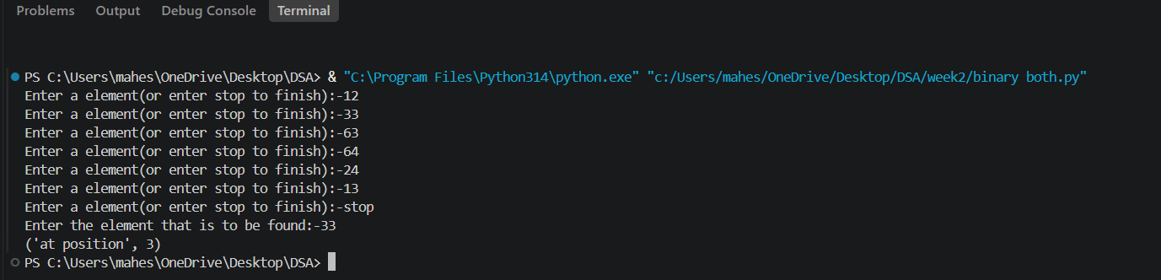
EXPLANATION:
This program uses the binary search technique to find a target element in a list.
- The function binary_search(arr, target) is defined to perform the search operation.
- Two variables are initialized:
  - low = 0: Represents the starting index of the list.
  - high = len(arr) - 1: Represents the last index of the list.
- A while loop runs as long as low <= high, ensuring the search space is valid.
- The middle index is calculated using mid = (low + high) // 2.
- The statement if arr[mid] == target: checks whether the middle element is equal to the target.
  - If true, the function returns "at position", mid.
- If the target is greater than the middle element (target > arr[mid]), the search continues in the right half by updating low = mid + 1.
- Otherwise, the search continues in the left half by updating high = mid - 1.
- The user inputs elements into the list a until "stop" is entered.
- The list is sorted using a.sort().
  - This ensures that even if the user enters an unsorted array, the binary search will still work correctly.
- The user enters the element to be searched, stored in variable b.
- The function is called using binary_search(a, b) and the result is printed.
ERROR TABLE:
Error | Correction
Indendation error | Give proper indendation
Empty array | Check that n >= 0 before running the loop.

LAB-3
1) Write a python program to implement bubble sort where the elements are taken from the user.
CODE:
def bubble_sort(arr):
n = len(arr)
for i in range(n - 1):
for j in range(n - 1 - i):
if arr[j] > arr[j + 1]:
arr[j], arr[j + 1] = arr[j + 1], arr[j]
return arr
arr = []
z = int(input("Enter the number of elements: "))
for k in range(z):
arr.append(int(input("Enter the element: ")))
#bubble_arr = arr.copy()
print("Original array:", arr)
print("Sorted array:", bubble_sort(arr))
OUTPUT:
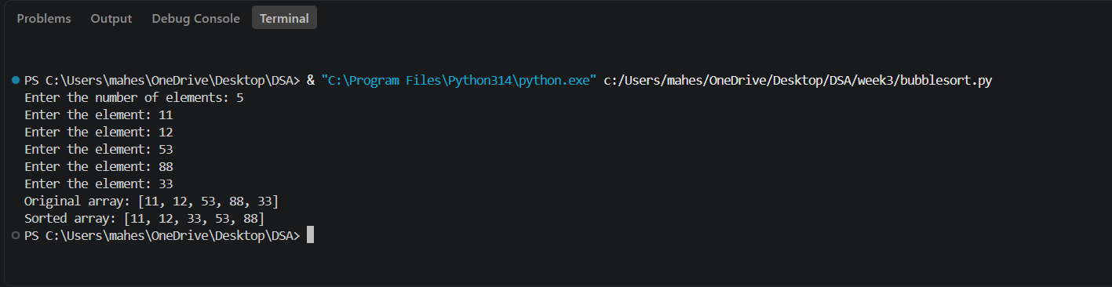
EXPLANATION:
- Bubble Sort is a simple comparison-based sorting algorithm.
- It repeatedly compares adjacent elements in the array.
- If two adjacent elements are in the wrong order, they are swapped.
- After each pass, the largest unsorted element moves to the end.
- The variable i controls the number of passes through the array.
- The variable j is used to compare adjacent elements.
- The comparison range decreases after every pass.
- The process continues until all elements are arranged in ascending order.
- Its time complexity is O(n²) in the best, average, and worst cases for this implementation.
- The function returns the sorted array after completing all passes.
ERROR TABLE:
No error
2) Write a python program to implement insertion sort where the elements are taken from the user.
CODE:
def insertion_sort(arr):
for i in range(1, len(arr)):
key = arr[i]
j = i - 1
while j >= 0 and arr[j] > key:
arr[j + 1] = arr[j]
j -= 1
arr[j + 1] = key
return arr
arr = []
z = int(input("Enter the number of elements: "))
for k in range(z):
arr.append(int(input("Enter the element: ")))
arr = arr.copy()
print("Original array:", arr)
print("sorted array:", insertion_sort(arr))
OUTPUT:
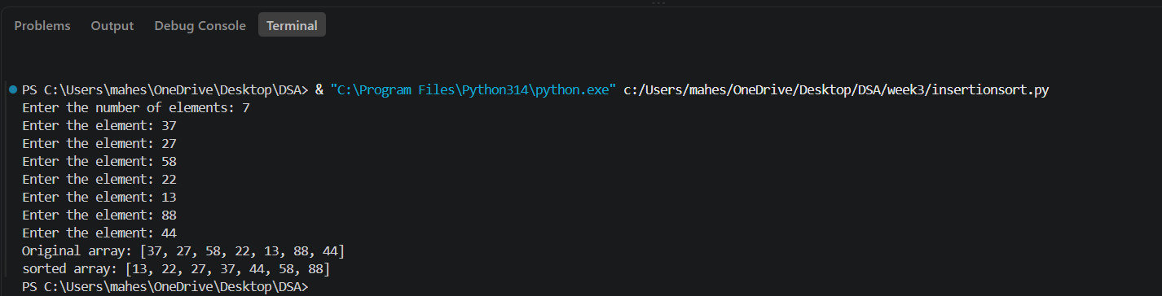
EXPLANATION:
- Insertion Sort is a comparison-based sorting algorithm.
- It builds the sorted array one element at a time.
- The algorithm starts from the second element of the array.
- The current element is stored in the variable key.
- It compares the key with the elements before it.
- Larger elements are shifted one position to the right.
- The key is inserted into its correct position.
- This process continues until all elements are sorted.
- Its time complexity is O(n²) in the average and worst cases.
- The function returns the array sorted in ascending order.

ERROR TABLE:
Error | Correction
Indendation error | Give proper indendation
Negative input | Check that z>= 0 before running the loop.

3) Write a python program to implement selection sort where the elements are taken from the user.
CODE:
def selection_sort(arr):
n = len(arr)
for i in range(n - 1):
min_index = i
for j in range(i + 1, n):
if arr[j] < arr[min_index]:
min_index = j
arr[i], arr[min_index] = arr[min_index], arr[i]
return arr
arr = []
z = int(input("Enter the number of elements: "))
for k in range(z):
arr.append(int(input("Enter the element: ")))
print("Sorted array:", selection_sort(arr))
OUTPUT:
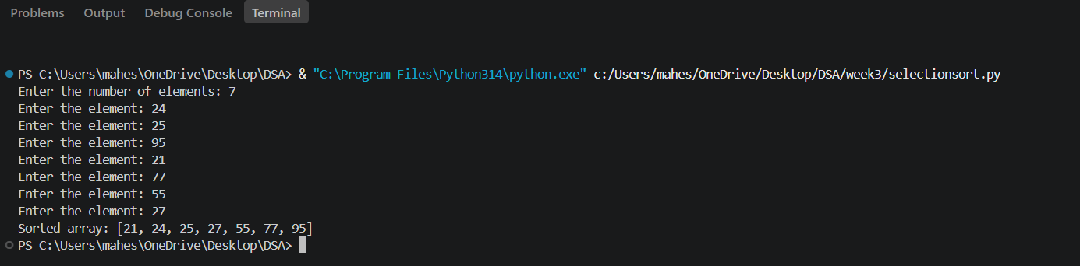
EXPLANATION:
- Selection Sort is a simple comparison-based sorting algorithm.
- It divides the array into a sorted part and an unsorted part.
- The algorithm starts from the first element of the array.
- It searches the unsorted part to find the smallest element.
- The index of the smallest element is stored in min_index.
- The smallest element is swapped with the first element of the unsorted part.
- This process is repeated until all elements are sorted.
- The algorithm sorts the given array in ascending order.
- Its time complexity is O(n²) in the best, average, and worst cases.
- The function returns the sorted array after completing the sorting process.

ERROR TABLE:
No error

